

Game Instructions

1.Main menu

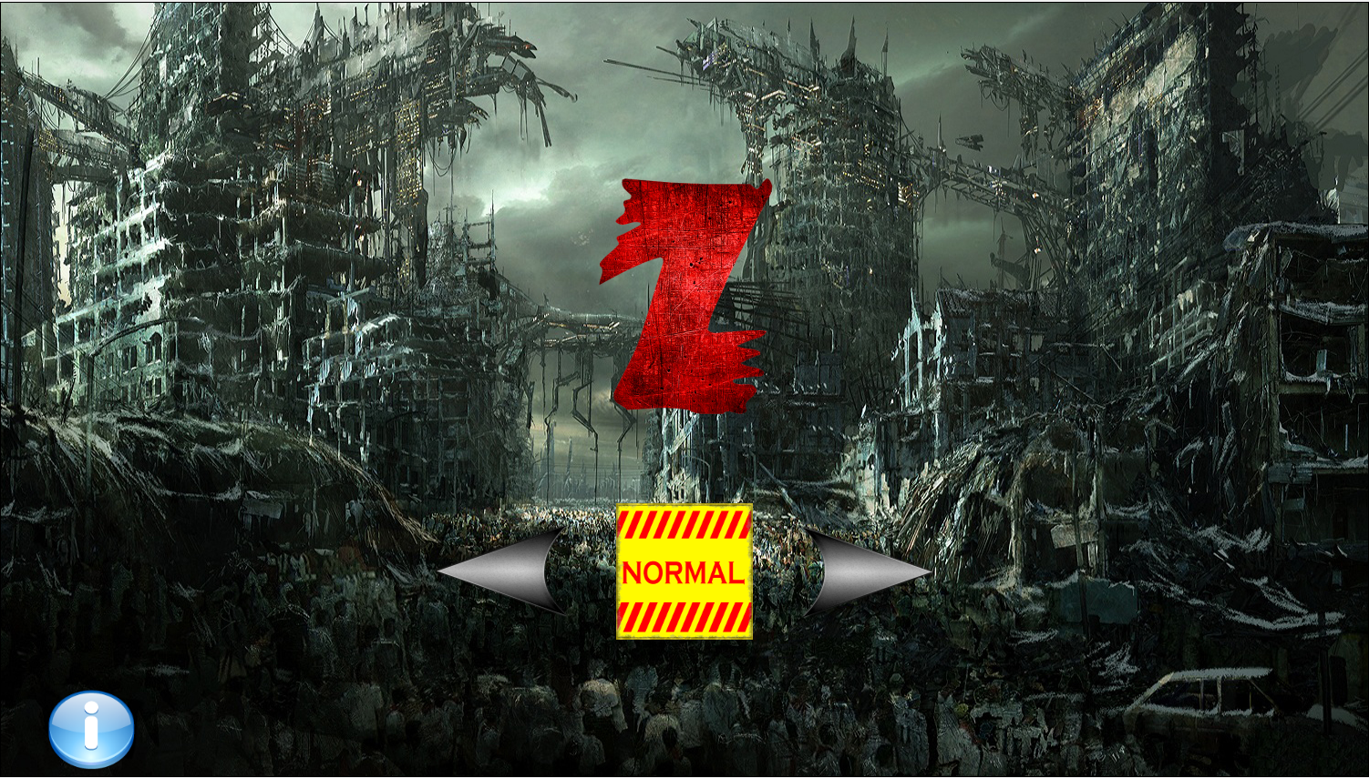

-Press the arrows to change the difficulties.(easy,normal, and hard)

-Press the yellow sign to start the game.

-Press the i button to see more information.

2.The game

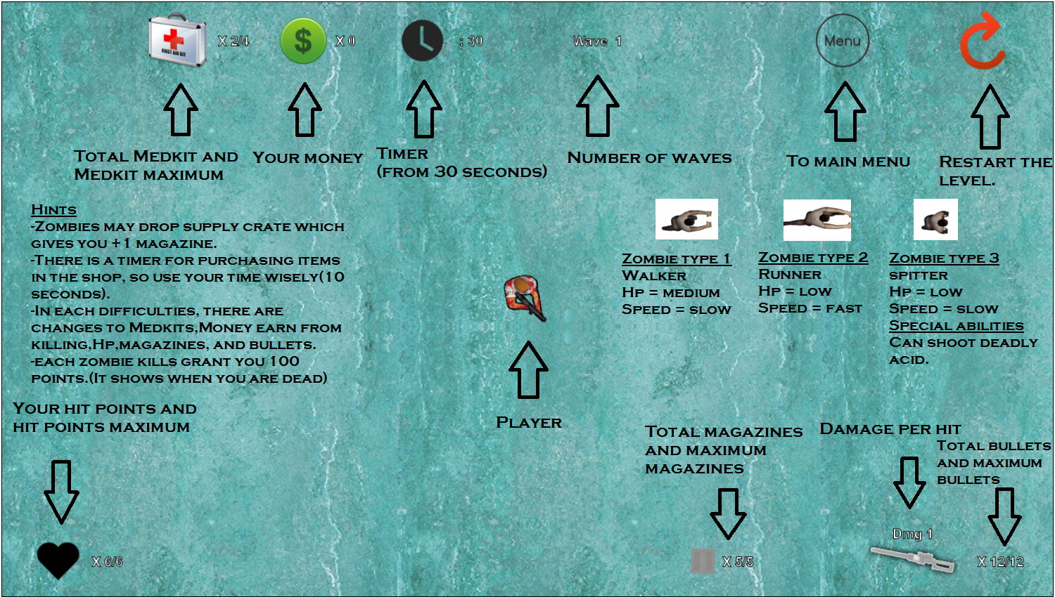-Supply crates also spawns randomly.

3.More instructions

-click anywhere on the information scene to chang scene.(Not the main menu button obviously)

-Your score will be shown when you died.